**FACE DETECTION MODELS AND THEIR COMPARATIVE STUDY**

**Objective:**

This report compares and analyzes the performance, strengths, and applications of three prominent face detection models: RetinaFace, MTCNN (Multi-task Cascaded Convolutional Networks), and YOLOv8 (You Only Look Once version 8)

**1.RetinaFace Model:**

RetinaFace employs a single-stage dense prediction framework that predicts face bounding boxes and facial landmarks simultaneously. It uses a multi-task loss function and feature pyramid network (FPN) to handle multi-scale detection.

**Output 1: The Result so obtained on inputting the image of woman, using RetinaFace Model**

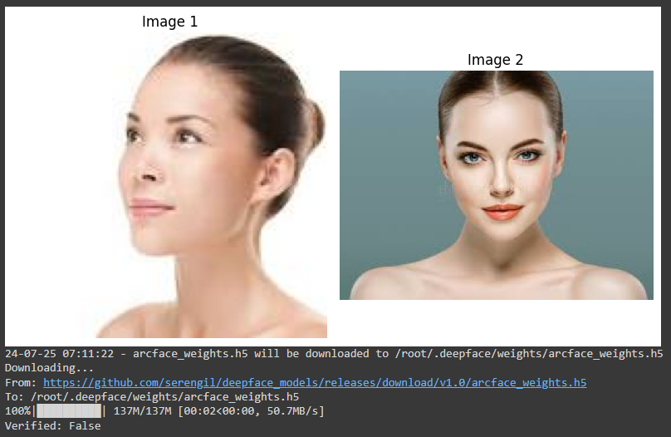

**Output 2: The Result so obtained on inputting the half image of man’s face, using RetinaFace Model**

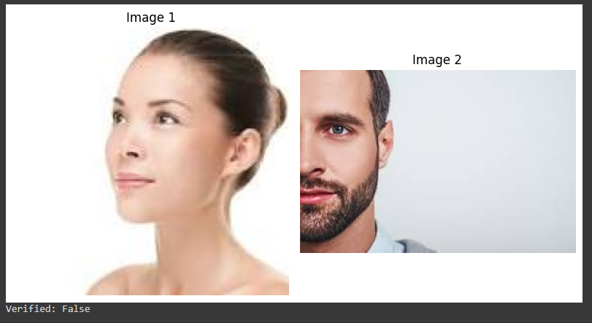

**Output 3: The Result so obtained on inputting side face of man’s image, using RetinaFace Model**

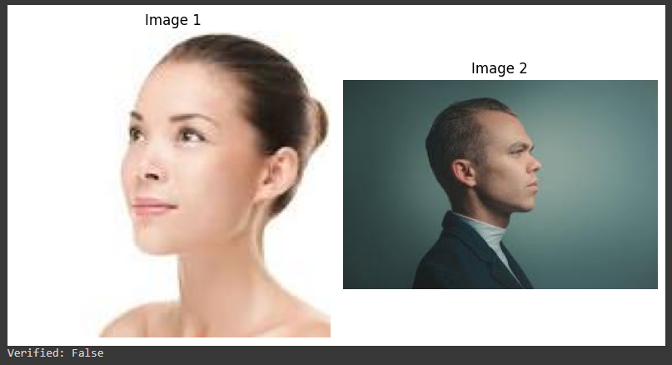

**Output 4: The Result so obtained on inputting the non-Facial image, using RetinaFace Model**

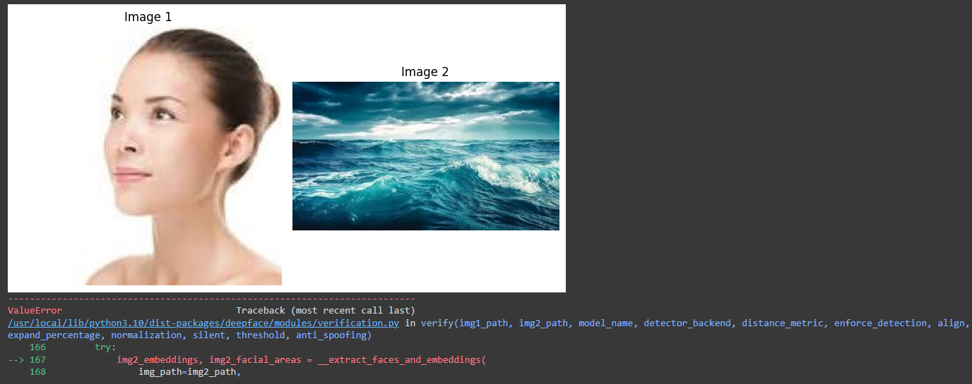

**Note: Accounts to an error executing the code, while having not found the facial features**

**MTCNN (Multi-task Cascaded Convolutional Networks):**

MTCNN is a multi-stage detection framework consisting of three stages: face detection, bounding box regression, and facial landmark localization.

**Output 1: The Result so obtained on inputting the side pose image, using MTCNN Model**

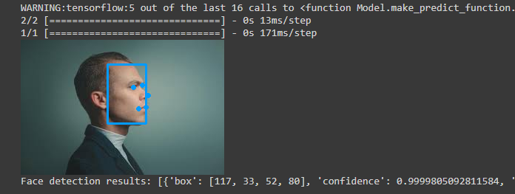

**Output 2: The Result so obtained on inputting the half face image, using MTCNN Model**

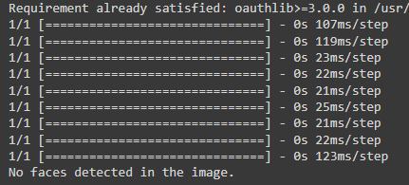

**Note: MTCNN fails to detect the half image of a person**

**YOLOv8 Model:**

YOLOv8 is a one-stage object detection model that can be adapted for face detection tasks. It predicts bounding boxes and class probabilities directly from full images in a single evaluation.

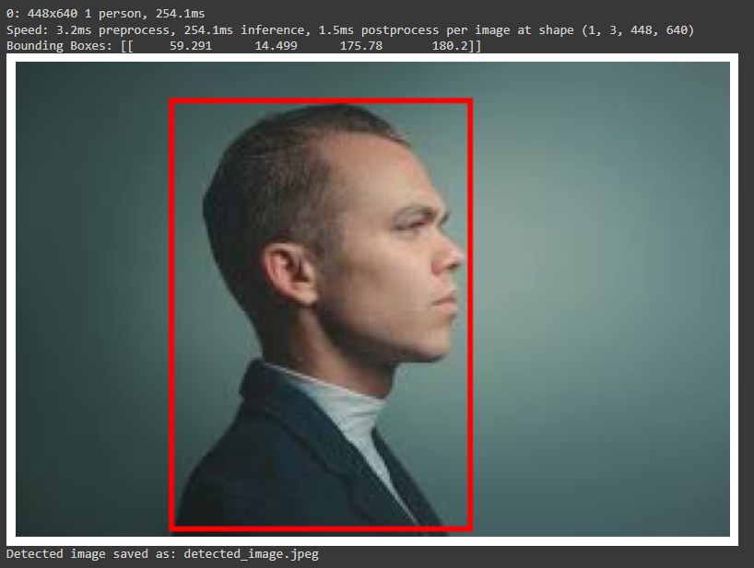**Output 1: The Result so obtained on inputting the man’s side pose image, using YOLOv8 Model**

**Output 2: The Result so obtained on inputting the person’s body, using YOLOv8 Model**

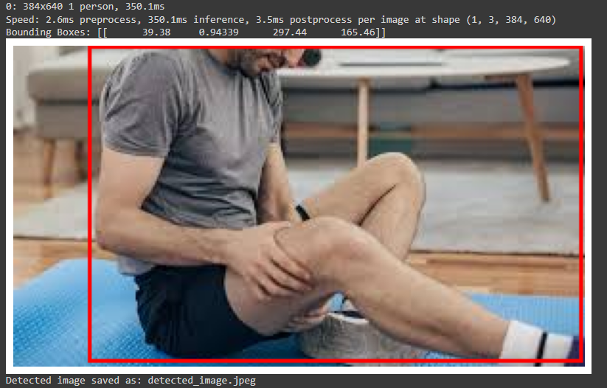

**Output 2: The Result so obtained on inputting the person’s body, using YOLOv8 Model**

**Output 3: The Result so obtained on inputting non- facial image, using YOLOv8 Model**

**Note: No detections found on giving random images**

**Output 3: The Result so obtained on inputting non- facial image, using YOLOv8 Model**

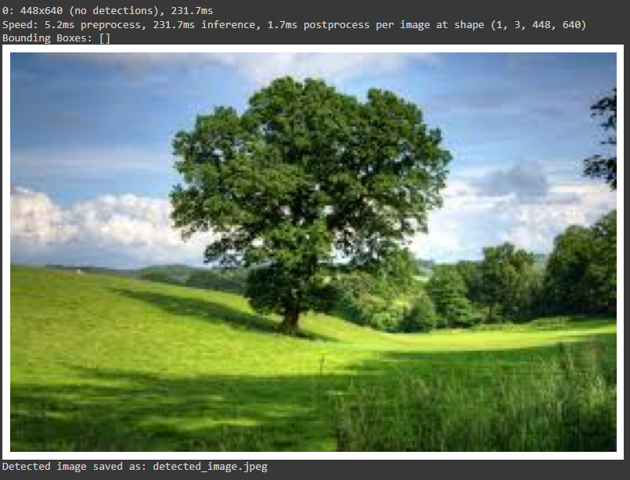

**HOG (Histogram of Oriented Gradients) and SVM (Support Vector Machine)**

**Output 1: The Result so obtained on inputting a facial image, using HOG SVM**

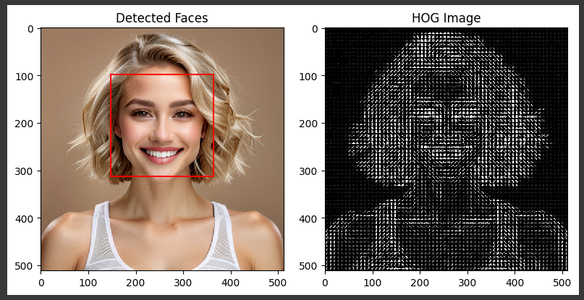

Insight: It bounds the detected face

**Output 2: The Result so obtained on inputting a half facial image, using HOG SVM**

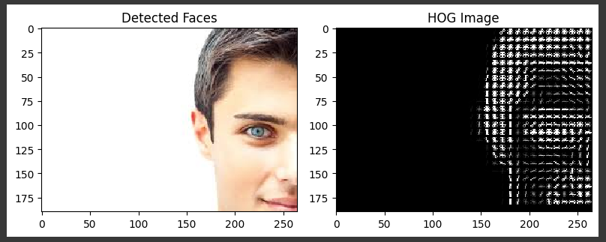

Note: It fails to detect the half facial image

Remarks: The model fails to detect the half facial image using HOG SVM model

**CASCADE classifier**

**Output 1: The Result so obtained on inputting non- facial image, using CASCADE Model**

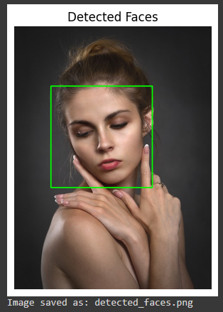

**Output 2: The Result so obtained on inputting non- facial image, using CASCADE Model**

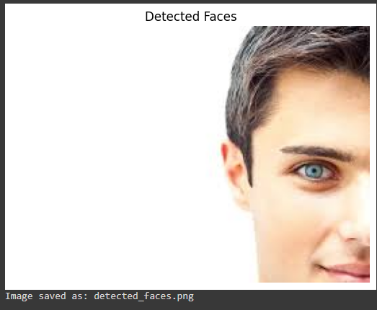

**Remarks:**

The **RetinaFace** model detects the facial images of front view, half face and side view as well, but encounters an error on finding the non-facial images that could be made more perfect to deliver the right output. **MTCNN** detects the facial front view image as well as side view but fails to detect the half face. **YOLOv8** detects the person and any other object with a bounding box.

The **HOG SVM and CASCADE** classifier is a good option to go with face detection, but it fails to detect the half facial image.

**Conclusion:**

In comparison with all the 5 models, Retina Face yields a best result in detecting the face. It is also good to go with combined models.

**Improvements:**

We need a model that perfectly detects and segregates the face and half facial images.